

GARAGE MANAGEMENT SYSTEM

Salesforce Developer



**Team ID : LTVIP2025TMID30689**

**Team Members :**

**Name Hall ticket no**

**Thota Naresh 226M1A4264**

**Sunkara Sushma Deepika 226M1A4258**

**Faculty Mentor :** P Venkata Chalam M.Tech(Ph.d) , Associate professor, Training and Placement Department,

BVC College Of Engineering, Palacharla**.**

SmartBridge

**Salesforce Garage Management System:**

## Executive Summary

This report details the implementation of a comprehensive Garage Management System (GMS) on the Salesforce platform, designed to streamline operations for automotive repair facilities. The system leverages Salesforce's robust capabilities to manage appointments, vehicles, customer relationships, inventory, billing, and work orders, enhancing operational efficiency and customer satisfaction. This documentation serves as a technical guide for the Salesforce Developer Internship project of **Sunkara Sushma Deepika**(Team ID: LTVIP2025TMID30689), outlining the configuration of custom objects, fields, automation tools (Flows, Apex Triggers), security models (Profiles, Roles, Sharing Settings), and analytical dashboards. The project demonstrates a practical application of Salesforce development principles to solve real-world business challenges.

## Introduction to Garage Management System (GMS)

The Garage Management System (GMS) is presented as a vital software solution specifically engineered to optimize the operations of automotive repair facilities, service centers, and garages. Its core purpose extends beyond mere task management, aiming to elevate service delivery, significantly improve operational efficiency, and cultivate enduring customer relationships. The system is designed with a user-friendly interface and powerful features that empower garages to maintain a competitive edge in the market, ensuring a seamless and satisfying experience for both their clientele and internal staff.

The strategic importance of the GMS is evident in its focus on building lasting customer relationships and enabling businesses to thrive in a competitive market. This emphasis highlights the system's role as a catalyst for business growth, moving beyond simple operational improvements to become a strategic asset. By fostering strong customer loyalty through efficient service and personalized interactions, the GMS directly contributes to repeat business and positive word-of-mouth referrals, which are crucial for sustained revenue growth. Furthermore, enhanced operational efficiency, achieved through streamlined workflows, allows for better resource allocation, potentially reducing costs or increasing service capacity. This dual focus on customer satisfaction and operational agility positions the GMS as a comprehensive solution for achieving both immediate gains and long-term market advantage.

## Key Features of the GMS Solution

The GMS offers a comprehensive suite of features meticulously tailored to meet the diverse needs of mechanics, service advisors, and business owners, thereby ensuring smoother workflows and heightened customer satisfaction. These features are designed to cover the entire lifecycle of garage operations :

* + **Appointment Scheduling:** This feature simplifies the process of booking services for customers, while

simultaneously enabling staff to manage daily schedules with greater efficiency. This leads to a reduction

in downtime and improved allocation of resources, optimizing the flow of work within the garage.1

* + **Vehicle Management:** The system maintains exhaustive records of vehicles, encompassing their complete service history, past repairs, and future maintenance schedules. It also tracks the real-time status of

vehicles during servicing, facilitating clearer and more proactive communication with customers.1

* + **Customer Relationship Management (CRM):** The GMS serves as a central repository for customer details and preferences. It automates the dispatch of service reminders, follow-up communications, and targeted

promotional offers, all designed to cultivate and strengthen customer loyalty.

* + **Inventory and Spare Parts Management:** This capability tracks stock levels of spare parts, automates reorder processes, and proactively prevents stock-outs. This ensures that mechanics consistently have the

necessary tools and parts readily available, minimizing delays in service.1

* + **Billing and Invoicing:** The system facilitates the rapid and accurate generation of professional invoices. It supports a variety of payment methods, allows for the application of discounts, and handles complex tax

calculations, streamlining the financial aspects of service delivery.1

* + **Work Order Management:** Detailed work orders can be created, outlining specific tasks, estimated costs, and timelines for each job. This functionality assists staff in prioritizing jobs effectively and ensures their

timely completion, enhancing overall productivity.1

* + **Reporting and Analytics:** The GMS provides valuable insights into key performance indicators (KPIs) such as revenue generation, job completion rates, and customer feedback. This analytical capability helps in

identifying emerging trends and pinpointing areas that require improvement, enabling data-driven strategic adjustments.1

## Introduction to Salesforce Platform

Salesforce is presented as a leading "customer success platform" and a "game-changing technology" specifically engineered to empower businesses in their efforts to sell, service, market, analyze, and connect with their customer base. It offers a suite of productivity-boosting features designed to facilitate smarter and faster sales processes.1

The description of Salesforce as a platform that helps businesses "sell, service, market, analyze, and connect" suggests it functions as a comprehensive ecosystem rather than a singular application. This multi-faceted capability is particularly advantageous for a Garage Management System, as it enables all critical aspects of garage operations— from initial customer interaction and service delivery to billing, inventory, and even marketing efforts—to be managed within a single, integrated environment. This holistic approach eliminates the need for disparate systems, allowing data to flow seamlessly between different functions. For instance, a customer's detailed service history can directly inform future personalized marketing campaigns, and completed work orders can automatically trigger billing processes. This integration reduces data silos, improves data accuracy, and provides a unified, comprehensive view of both the customer and the business operations, offering a significant advantage over fragmented, stand-alone systems.

## Why Salesforce for GMS?

Historically, business operations such as contact management, email correspondence, and tracking prospective deals were often disorganized and managed across various disconnected tools. Salesforce addresses this challenge by consolidating these functions onto a unified, secure platform. This consolidation allows businesses to manage relationships with prospects and customers, foster collaboration among employees and partners, and store critical data securely, accessible from any location.

The transition from fragmented, disorganized data to a securely stored and universally accessible platform represents a fundamental benefit. For a GMS, this translates directly into real-time access to vital information such as vehicle history, customer preferences, and current inventory levels. This immediate access significantly impacts service quality and speed. For example, a service advisor can instantly retrieve a vehicle's complete maintenance record, allowing for more informed recommendations and faster diagnostics. For multi-location garages or mobile service advisors, the ability to access up-to-date information from anywhere ensures consistent service delivery and operational efficiency, ultimately enhancing the customer experience.



1. **Salesforce Environment Setup**

This section outlines the initial steps required to establish a Salesforce developer environment, which is an essential prerequisite for building and thoroughly testing the Garage Management System.

## Creating Your Salesforce Developer Account

To begin the development process, a dedicated Salesforce Developer Account must be created. This account provides a specialized environment tailored for development and testing purposes.

The step-by-step instructions for creating this account are as follows:

1. Navigate to the official Salesforce Developer signup page by opening a web browser and entering the URL: https://developer.salesforce.com/signup.
2. Upon reaching the sign-up form, meticulously complete all required fields with the following personalized details, ensuring accuracy for account creation and future access 1:
   * **First Name:** Thota
   * **Last Name:** Naresh
   * **Email:** [naeshthota2628@gmail.com](mailto:naeshthota2628@gmail.com)
   * **Role:** Developer (This selection designates the account for development activities)
   * **Company:** Your College Name (e.g., "Smartbridge Internship" or "Your University Name," representing

the affiliation for the internship project)

* + **Country:** India
  + **Postal Code:** Your Pin Code
  + **Username:** A unique identifier that combines your name and company, typically formatted as

[username@organization.com](mailto:username@organization.com) (for example, [thotanaresh@smartbridge.com).](mailto:thotanaresh@smartbridge.com) It is important to note that

this username does not need to be an actual, active email address but must adhere to the specified format.

1. After all details have been accurately entered, click the "sign me up" button to submit the registration form

and proceed with the account creation process.1

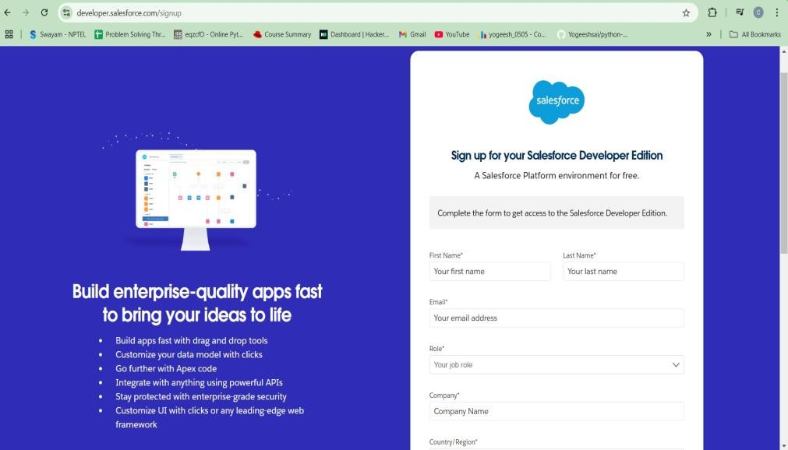

## Account Activation

Following the successful submission of the sign-up form, the newly created Salesforce Developer Account must be activated to gain full access to the development environment.

The activation process involves the following steps:

1. Access the inbox of the email address provided during the sign-up process (naeshthota2628@gmail.com).1
2. Locate the verification email sent by Salesforce. Within this email, click on the "verify account" link. This

action will activate the Salesforce Developer Edition account, making it ready for use.

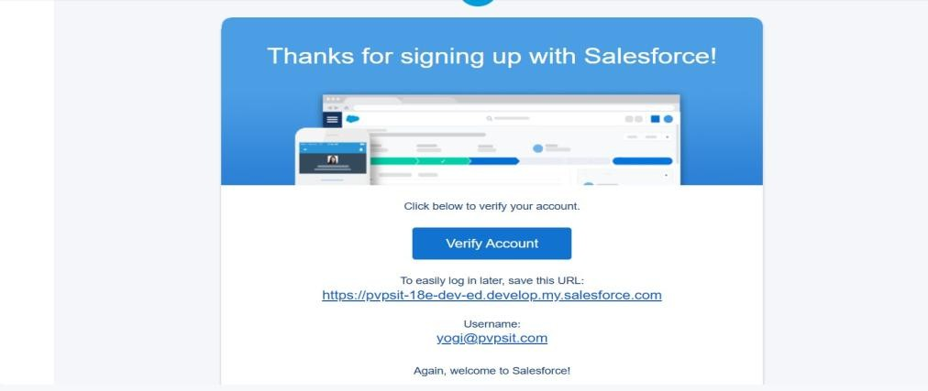

The utilization of a "Developer Edition" is a crucial aspect of this internship project. This specific type of Salesforce environment provides a free, isolated sandbox where developers can build, configure, and test applications without any risk of impacting a live production system. This isolation is invaluable for learning and

experimentation, as it allows for the free exploration of Salesforce capabilities, including making mistakes and

learning from them, without any adverse consequences on real business operations. This controlled environment is perfectly aligned with the learning objectives of an internship, providing a safe and effective space for practical skill development.

**OBJECT**

## What Is an Object?

Salesforce objects are database tables that permit you to store data that is specific to an organization. What are the types of Salesforce objects

Salesforce objects are of two types:

1. **Standard Objects**: Standard objects are the kind of objects that are provided by salesforce.com such as users, contracts, reports, dashboards, etc.
2. **Custom Objects**: Custom objects are those objects that are created by users. They supply information that is unique and essential to their organization. They are the heart of any application and provide a structure for sharing data.

## Create Customer DetailsObject To create an object:

1. From the setup page >> Click on Object Manager >>Click on Create >> Click on Custom Object.
2. Enter the label name >> CustomerDetails
3. Plural label name >>Customer Details
4. Enter RecordName Label and Format
   1. Record Name >> CustomerName
   2. DataType >> Text
5. Click on Allow reports and Track FieldHistory,
6. Allow search>> Save.

## Create Appointment Object To create an object:

1. From the setup page >> Click on Object Manager >>Click on Create >> Click on Custom Object.
2. Enter the label name >> Appointment
3. Plural label name >>Appointments
4. EnterRecord Name Label and Format

Record Name >> Appointment Name

* 1. DataType >> Auto Number
  2. Display Format >> app-{000}
  3. Starting number >> 1

1. Click on Allow reports and Track FieldHistory, 3. Allow search >> Save.

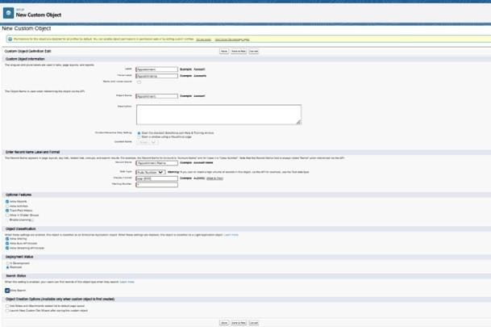

## Create Service records Object To create an object:

1. From the setup page >> Click on ObjectManager >> Click on Create>> Click on Custom Object.
2. Enter the label name >> Service records
3. Plural label name >>Service records
4. EnterRecord Name Label and Format
   1. Record Name >>Service recordsName DataType >> Auto Number
5. Display Format >> ser-{000}
6. Starting number >> 1
7. Click on Allow reports and Track FieldHistory,
8. 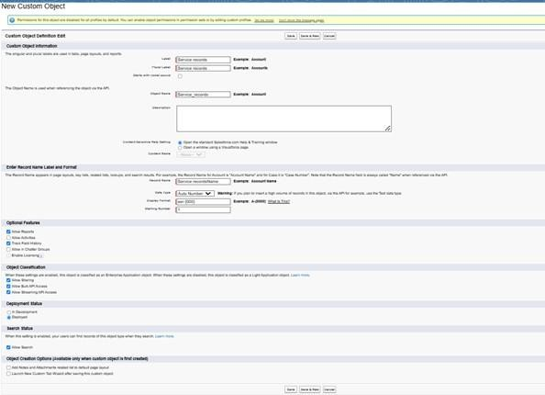Allow search >> Save.

## Create Billing details and feedback Object To create an object:

1. From the setup page >> Click on Object Manager >>Click on Create >> Click on Custom Object.
2. Enter the label name >> Billing details and feedback
3. Plural label name >>Billing details and feedback
4. Enter RecordName Label and Format
   1. Record Name >> Billing details and feedbackName
   2. DataType >> Auto Number Display Format >> bill-{000}

d. Starting number >> 1

1. Click on Allow reports and Track FieldHistory,
2. Allow search>> Save.

# Tabs

**What is Tab** : A tab is like a user interface that is used to build records for objects and to view the records in the objects.

## Types of Tabs:

1. **Custom Tabs**

Custom object tabs are the user interface for custom applications that you build in salesforce.com.They look and behave like standard salesforce.com tabs such as accounts, contacts, and opportunities.

## Web Tabs

Web Tabs are custom tabs that display web content or applications embedded in the salesforce.comwindow. Web tabs make it easier for your users to quickly access content and applications they frequently use without leaving the salesforce.com application.

## Visual force Tabs

Visual force Tabs are custom tabs that display a Visual force page. Visual force tabs look and behave like standard salesforce.com tabs such as accounts, contacts, and opportunities.

## Lightning Component Tabs

Lightning Component tabs allow you to add Lightning components to the navigation menu in Lightning Experience and the mobile app.

## Lightning Page Tabs

Lightning Page Tabs let you add Lightning Pages to the mobile app navigation menu. Lightning Page tabs don't work like other custom tabs. Once created,they don't show up on the All Tabs page when you click the Plus icon that appears to the right of your current tabs. Lightning Page tabs also don't show up in the Available Tabs list when you customise the tabs for your apps.

## Creating a Custom Tab

**To create a Tab:(Customer Details)**

1. Go to setup page >> type Tabs in Quick Find bar >>click on tabs >> New (under custom object tab)
2. Select Object(Customer Details) >> Select the tab style>> Next (Add to profiles page) keep it as default >>Next (Add to Custom App) uncheck the include tab . Make sure that the Append tab to uninterestingness personal customizations is checked.
3. Click save.

## Creating RemainingTabs

* 1. Now create the Tabs for the remaining Objects, they are “ Appointments, Service records,Billing details and feedback”.
  2. Follow the same steps as mentioned in Activity -1 .

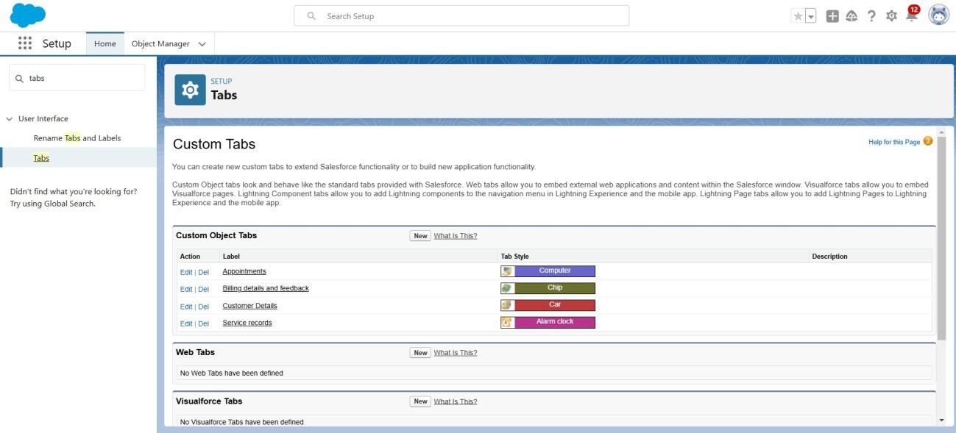

# The Lightning App

An app is a collection of items that work together to serve a particular function. In Lightning Experience, Lightning apps give your users access to sets of objects,tabs, and other items all in one convenient bundle in the navigation bar.

Lightning apps let you brand your apps with a custom colour and logo. You can even include a utility bar and Lightning page tabs in your Lightning app. Members of your org can work more efficiently by easily switching between apps.

## Create a Lightning App

**Cocreate a lightning app page:**

Go to setup page >> search “app manager”in quick find >> select “app manager”>> click on New lightning App.

1. Fill the app name in app details as Garage Management Application >> Next >>

(App option page) keep it as default>> Next >>(Utility Items) keep it as default >>Next.

1. To Add Navigation Items:
2. Select the items (Customer Details,Appointments, Service records,Billing details and feedback, Reports and Dashboards) from the search bar and move it using the arrow button >>Next.
3. 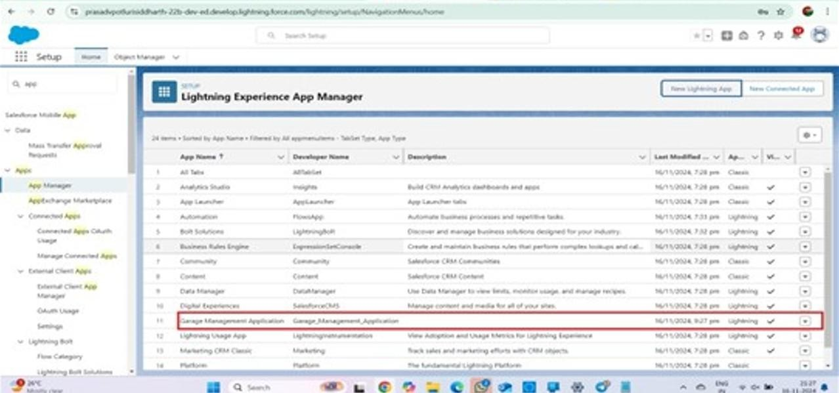To Add User Profiles:Search profiles (System administrator) in the search bar >> click on the arrow button >> save & finish.

# Fields

When we talk about Salesforce, Fields represent the data stored in the columns of a relational database. It can also hold any valuable information that you require for a specific object. Hence, the overall searching, deletion, and editing of the records become simpler and quicker.

Types of Fields

1. Standard Fields
2. Custom Fields

## Creation of fields for the Customer Details object

1. **Cocreate fields in an object:**
   1. Go to setup >>click on ObjectManager >> type object name(Customer Details) in search bar

>> click on the object.

* 1. Nowclick on “Fields& Relationships” >>New
  2. Select Data Type as a “Phone”
  3. Click on next.
  4. Fill the Above as following:
     1. FieldLabel: Phone number ii. FieldName : gets auto generated iii. Click on Next >> Next >>Save and new.

Note: Follow the above steps for the remaining field for the same object.

## Cocreate another fields in an object:

* 1. Go to setup >>click on ObjectManager >> type object name(Customer Details) in search bar

>> click on the object.

* 1. Nowclick on “Fields& Relationships” >>New
  2. Select Data type as a “Email”and Click on Next
  3. Fill the Above as following:
  4. Field Label: Gmail
  5. Field Name : gets auto generated
  6. Click on Next >>Next >> Save and new.

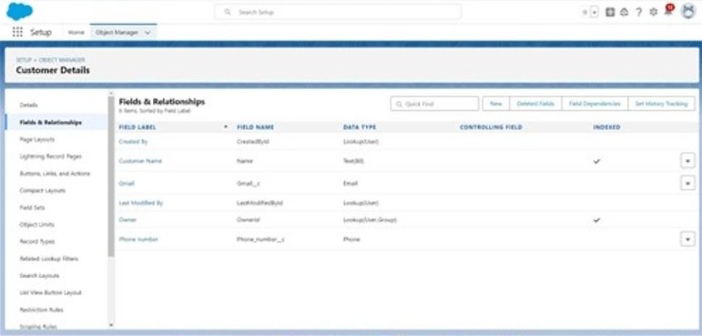

## Creation of Lookup Fields

**Creation of Lookup Field on Appointment Object:**

1. Go to setup>> click on Object Manager>> type object name( Appointment ) in the search bar >> click on the object.
2. Now click on “Fields& Relationships” >>New
3. Select “Look-up relationship” as data type and click Next.
4. Select the related object“ Customer Details”and click next.
5. Next >> Next >>Save.

Note: Make sure you complete Activity4 Before continuing.

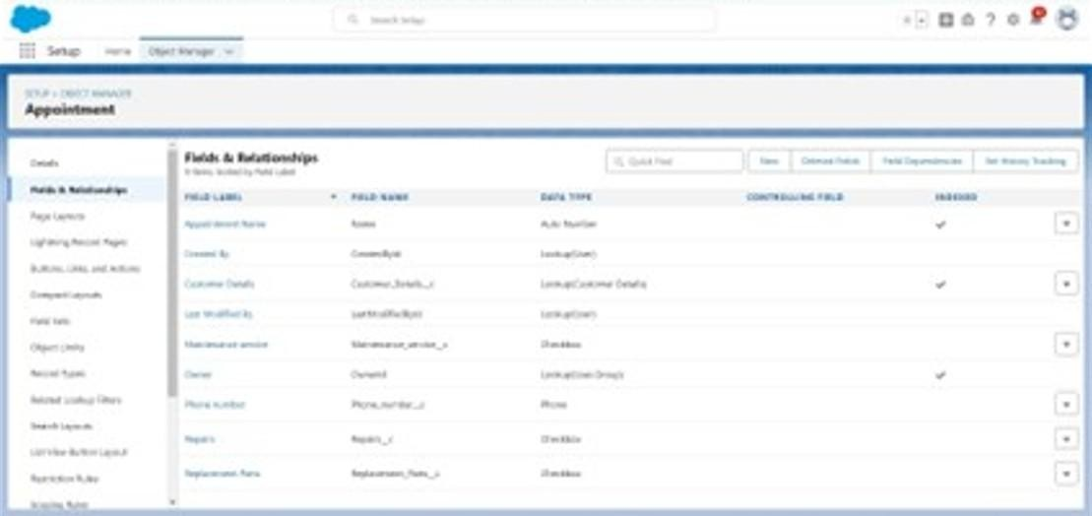

## Creation of Lookup Field on Service recordsObject :

1. Go to setup >> click on Object Manager >>type object name( Service records) in
   1. search bar >> click on the object.
2. Now click on “Fields & Relationships” >>New
3. Select “Look-up relationship” as data type and click Next.
4. Select the related object “ Appointment ” and click next.
5. Make it a required field so click on Required.
6. Scroll down for LookupFilter and click on Show filter settings.
7. Now add the filter criteria.
8. Field : Appointment: Appointment Date >>Operator : less than >>select field >> Appointment: Created Date
9. Filter type should be Required.
10. Error Message : Value does not match the criteria.
11. Enable the filter by click on Active.
12. Next >> Next >>Save.

## Creation of LookupField on Billingdetails and feedbackObject :

1. Go to setup>> click on Object Manager>> type object name( Billing details and feedback ) in search bar >> click on the object.
2. Now click on “Fields& Relationships” >>New.
3. Select “Look-up relationship” as data type and click Next.
4. Select the related object “ Service records” and click next.
5. Nclick next >>Save & new.

## Creation of CheckboxFields

**Creation of Checkbox Field on Appointment Object :**

1. Go to setup >> click on Object Manager >>type object name( Appointment ) in search bar >> click on the object.
2. Now click on “Fields & Relationships” >>New.
3. Select “Check box” as data type and click Next.
4. Give the Field Label : Maintenance service
5. Field Name : is auto populated
6. Default value : unchecked
7. Click on next >>next >> save.

## Creation of AnotherCheckbox Field on Appointment Object:

1. Repeat the steps form 1 to 3.
2. Give the FieldLabel : Repairs
3. Field Nee : is auto populated
4. Default value : unchecked
5. Click on next >> next >> save.
6. Follow the same and create another checkbox with given names
7. Give the Field Label: Replacement Parts
8. Field Nee : is auto populated
9. Default value : unchecked
10. Click on next >>next >> save.

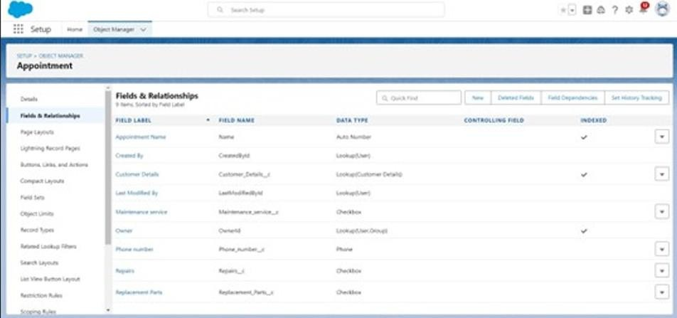

## Creation of Checkbox Field on Service records Object :

1. Go to setup >> click on Object Manager >>type object name( Service records) in search bar >>click on the object.
2. Now click on “Fields& Relationships” >>New.
3. Select “Check box” as data type and click Next.
4. Give the Field Label : Quality Check Status
5. Field Nee : is auto populated
6. Default value : unchecked
7. 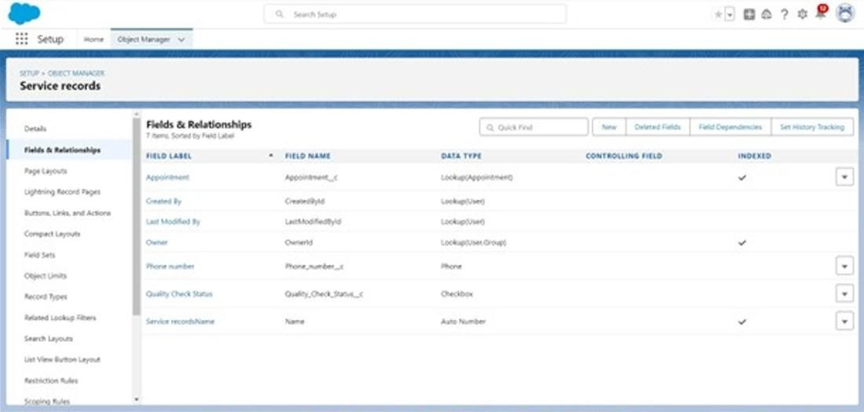Click on next >>next >> save

## Creation of date Fields

**Creation of Date Field on Appointment Object :**

1. Go to setup >>click on Object Manager >>type object name( Appointment ) in the search bar >> click on the object.
2. Nowclick on “Fields& Relationships” >>New.
3. Select “Date”as data type and clickNext.
4. Give the Field Label : Appointment Date
5. Field Nee : is auto populated
6. Make it as a Required field by click on the RequireRequired option
7. 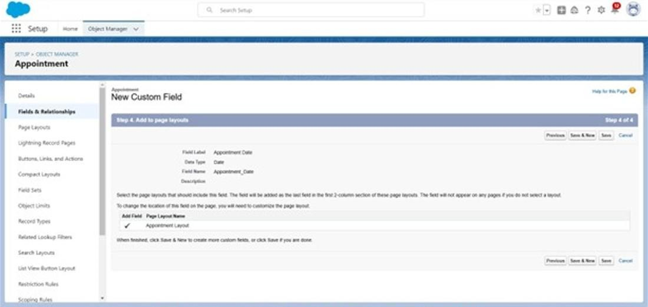on next >>next >> save.

## Creation of Currency Fields

**Creation of Currency Field on Appointment Object:**

1. Go to setup >> click on Object Manager >>type object name( Appointment ) in the search bar >> click on the object.
2. Now click on “Fields& Relationships” >>New.
3. Select “Currency” as data type and click Next.
4. Give the Field Label : Service Amount
5. Field Nee : is auto populated
6. Click on next
7. Give read only for all the profiles in field level security for profile.
8. Click on next > > save.

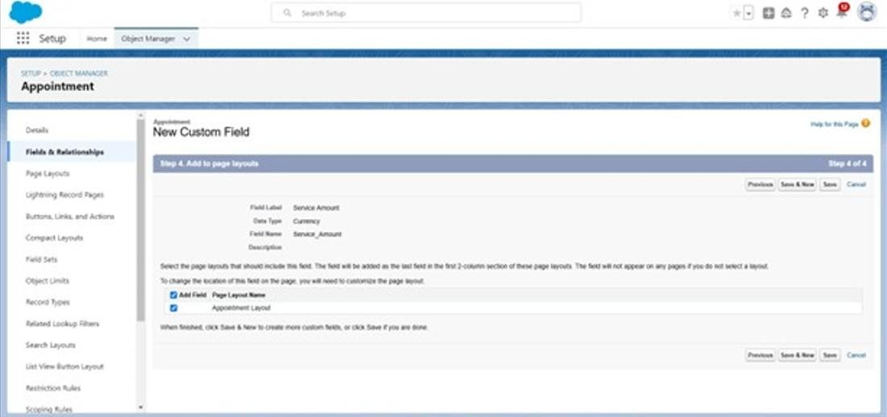

## Creation of CurrencyField on Billingdetails and feedbackObject :

1. Follow the same steps as mentioned above in Billingdetails and feedbackObject.
2. Change the label name as mentioned.
3. Give the Field Label : PaymentPaid
4. 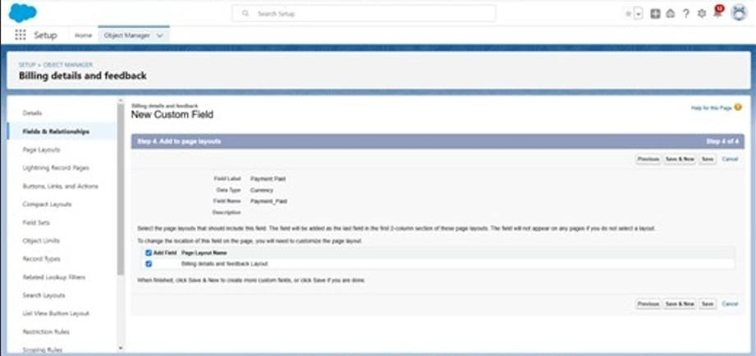Field Nee : is auto populated

## Creation of Text Fields

Go to setup >>click on Object Manager >>type object name( Appointment ) in the search bar >> click on the object.

1. Now click on “Fields &Relationships” >> New.
2. Select “Text” as data type and click Next.
3. Give the FieldLabel : Vehicle number plate
4. Field Name : is auto populated
5. Length : 10
6. Make field as Required and Unique.
7. Click on next >>next >> save.

## Creation of Text Fields in Billing details and feedback object:

1. Go to setup >> click on Object Manager >>type object name( Billing details and feedback ) in search bar >> click on the object.
2. Now click on “Fields& Relationships” >>New.
3. Select “text” as data type and click Next.
4. Give the Field Label : Rating for service
5. Field Name : is auto populated
6. Length : 1
7. Make field as Required and Unique.
8. Click on next >> next >> save

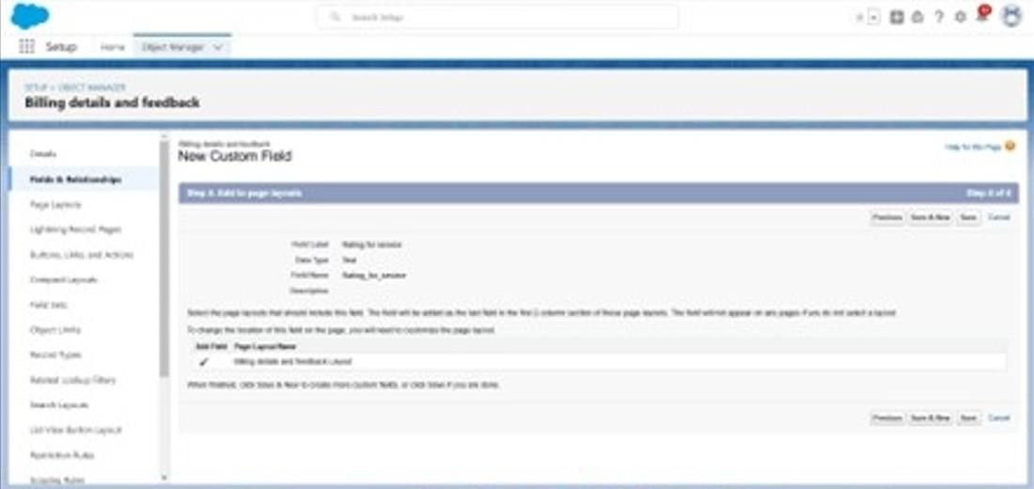

## Creation of Picklist Fields

**Creation of Picklist Fields in Service records object :**

1. Go to setup >>click on ObjectManager >> type object name(Service records) in search bar >>click on the object.
2. Click on fields &relationship >> click on New.
3. Select Data type as “Picklist” and click Next.
4. Enter Field Label as “Service Status”,under values select “Enter values,with each value separated by a new line" and enter values as shown below.
5. The values are: Started, Completed.
6. Click Next.
7. Next >>Next >> Save.

## Creation of Picklist Fields in Billing details and feedback object:

1. Go to setup >>click on Object Manager >>type object name(Billing details and feedback) in search bar >> click on the object.
2. Click on fields &relationship >> click on New.
3. Select Data type as “Picklist” and click Next.
4. Enter FieldLabel as “PaymentStatus”, under values select “Enter values,with each value separated by a new line" and enter values as shown below.
5. The values are: Pending,Completed.
6. Click Next.
7. 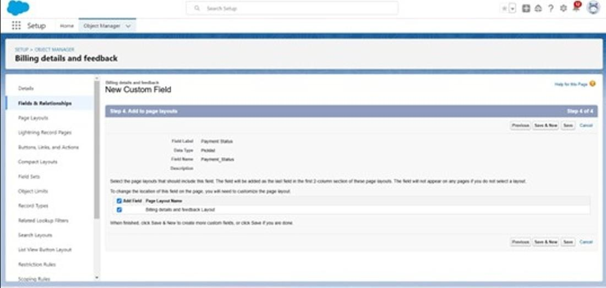Next >>Next >> Save.

## Creating Formula Field in Service records Object

1. Go to setup >>click on ObjectManager >> type object name(Service records) in search bar >> click on the object.
2. Click on fields &relationship >> click on New.
3. Select Data type as “Formula” and click Next.
4. Give Field Label and Field Name as “service date” and select formula return type as “Date” and click next.
5. Insert field formula should be : CreatedDate click “Check Syntax” .
6. Click next >> next >> Save.

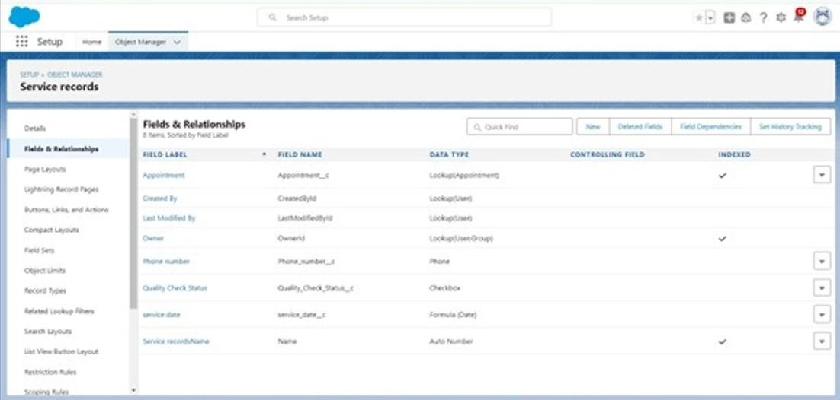

## Validation rule

Validation rules are applied when a user tries to save a record and are used to check if the data meets specified criteria. If the criteria are not met, the validation rule triggers an error message and prevents the user from saving the record until the issues are resolved.

## To create a validation rule to an Appointment Object

1. Go to the setup page >> click on object manager >> From drop down click edit for Appointment object.
2. Click on the validation rule >> click New.
3. Enter the Rule name as “ Vehicle ”.
4. Insert the Error Condition Formula as : - NOT(REGEX( Vehicle_number_plate c , "[A-Z]{2}[0-9]{2}[A- Z]{2}[0-9]{4}"))

Enter the Error Message as “Please enter valid number ”, select the Error location as Field and select the field as “Vehicle number plate”, and click Save.

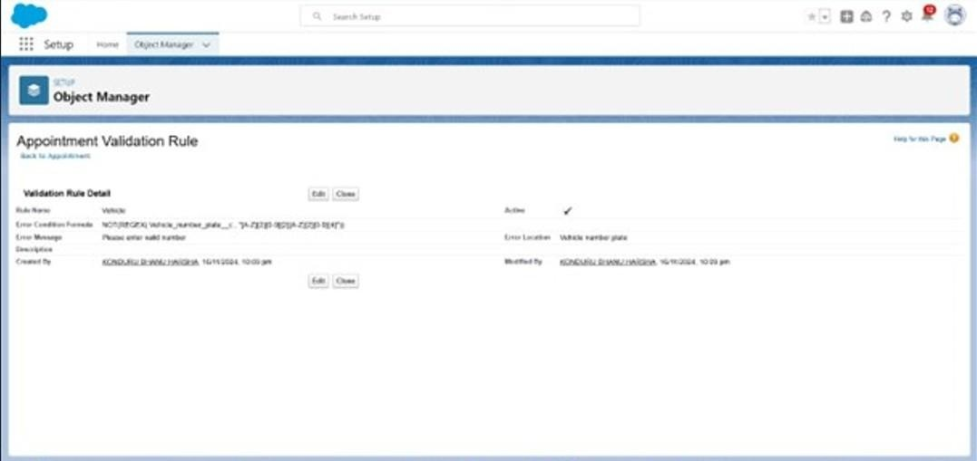

## To create a validation rule to an Service recordsObject

1. Go to the setup page >> click on object manager >> From drop down click edit for Service records object.
2. Click on the validation rule >> click New.
3. Enter the Rule name as “ service_status_note ”.
4. Insert the Error Condition Formula as : -

NOT( ISPICKVAL( Service_Statusc , "Completed"))

Enter the Error Message as “still it is pending”,select the Error location as Field and select the field as “Service status”, and click Save.

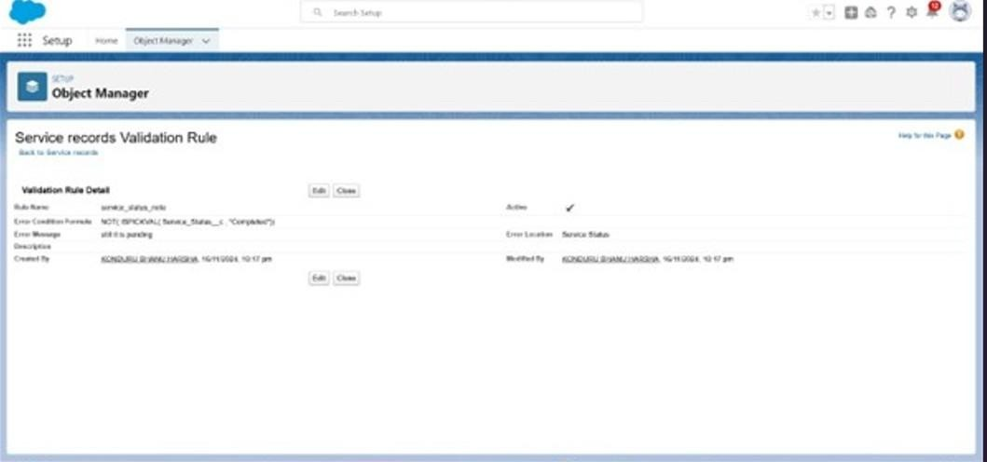

## To create a validation rule to an Billing details and feedback Object

1. Go to the setup page >> click on object manager>> From drop down clicked it for Billing details and feedback object.
2. Click on the validation rule >> click New.
3. Enter the Rule name as “ rating_should_be_less_than_5”.
4. Insert the Error Condition Formula as : -

NOT( REGEX( Rating_for_servicec , "[1-5]{1}"))

Enter the Error Message as “rating should be from 1 to 5”, select the Error location as Field and select the field as “Rating for Service”, and click Save.

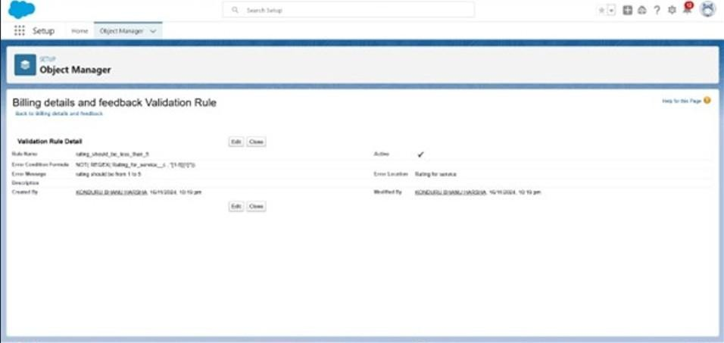

## Duplicate rule To create a matching rule to an Customer detailsObject

1. Go to quick find box in setup and search for matching Rule.
2. Click on matching rule >> click on New click on
3. elect the object as Customer details and click Next.
4. Give the Rule name : Matchingcustomer details
5. Unique name : is auto populated
6. Define the matching criteria as
7. Field Matching Method
   1. Gmail Exact
   2. Phone Number Exact
8. Click save.
9. After Saving Click on Activate.

## To create a Duplicaterule to an Customer detailsObject

1. Go to quick find box in setup and search for Duplicate rules.
2. Click on Duplicate rule >> click on New Rule >> select customer details object.
3. Give the Rule name as : Customer Detail duplicate
4. Scroll a little in Matching rule section
5. Select the matching rule : Matchingcustomer details
6. And Click on save.
7. After saving the Duplicate Rule, Click on Activate.

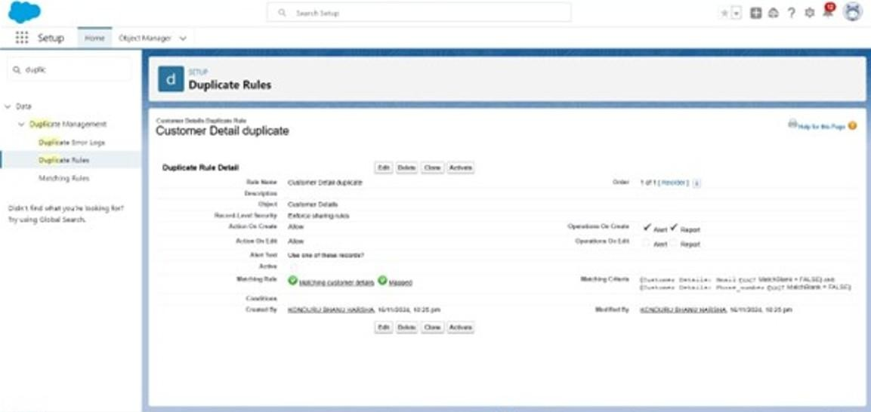

# Profiles

A profile is a group/collection of settings and permissions that define what a user can do in salesforce. Profile controls“Object permissions, Field permissions, User permissions, Tab settings, App settings, Apex class access, Visual force page access, Page layouts, Record Types, Login hours & Login IP ranges.You can define profiles by the user's job function.For example System Administrator, Developer, Sales Representative.

## Manager Profile

**To create a new profile:**

* 1. Goto setup >>type profiles in quick find box >>click on profiles>> clone the desired profile (Standard User) >>enter profile name (Manager) >> Save.
  2. While still on the profile page, then click Edit.
  3. Select the Custom App settings as default for the Garagemanagement.
  4. Scroll down to Custom Object Permissions and Give access permissions for Appointments,Billing details and feedback , service records and customer details objects as mentioned in the below diagram.
  5. Changing the session times out after should be “ 8 hours of inactivity”.
  6. Change the password policies as mentioned :
  7. User passwords expire in should be “ never-ending expires
  8. minimum password length should be “ 8 ”, and clicks ave.

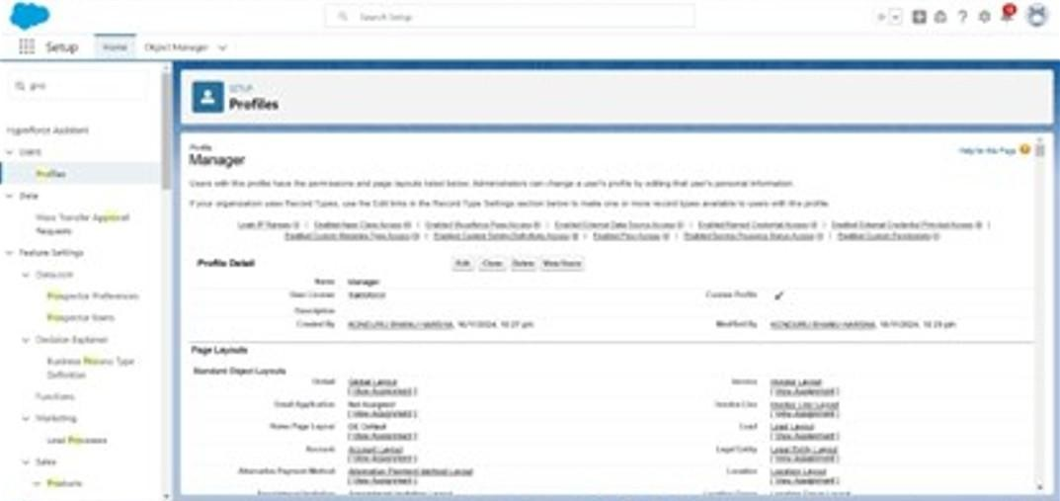

## Sales person Profile

1. Goto setup >>type profiles in quick find box >>click on profiles>> clone the desired profile (Salesforce PlatformUser) >> enter profile name (sales person) >> Save.
2. While still on the profile page, then click Edit.
3. Select the Custom App settings as default for the Garage management.
4. Scroll down to Custom Object Permissions and Give access permissions for Appointments,Billing details and feedback , service records and customer details objects as mentioned in the below diagram.
5. 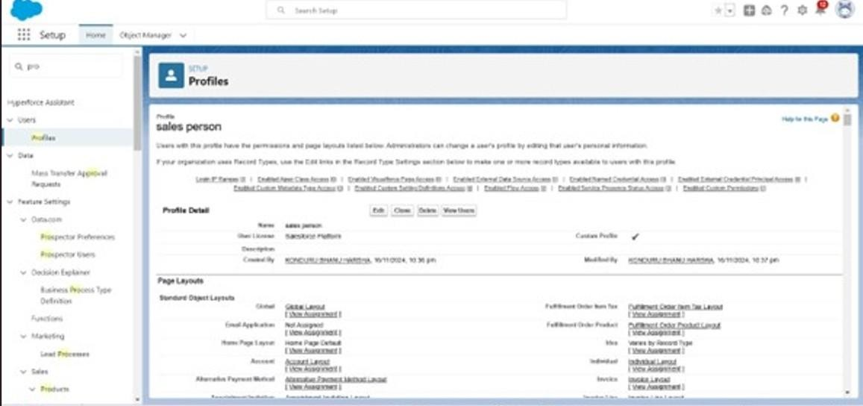And click save.

# Role &Role Hierarchy

A role in Salesforce defines a user's visibility access at the record level. Roles may be used to specify the types of access that people in your Salesforce organization can have to data. Simply put, it describes what a user could see within the Salesforce organization.

## Creating Manager Role

1. Go to quick find >>Search for Roles >> click on set up roles.
2. Click on ExpandAll and click on add role under whom this role works.
3. Give Label as “Manager” and Role name gets auto populated. Then click on Save.

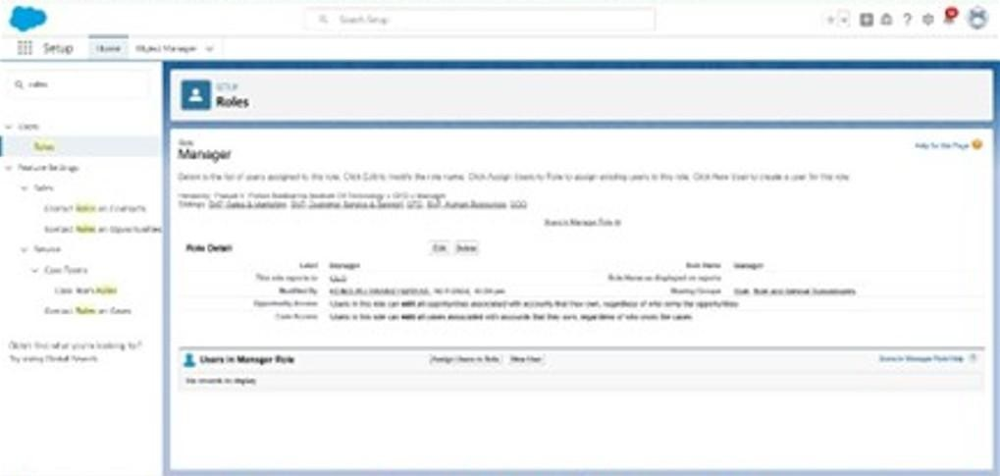

## Creating another roles

1. Go to quick find >>Search for Roles >> click on set up roles.
2. Click plus on CEO role, and click add role under manager.
3. Give Label as “sales person” and Role name gets auto populated. Then click on Save.

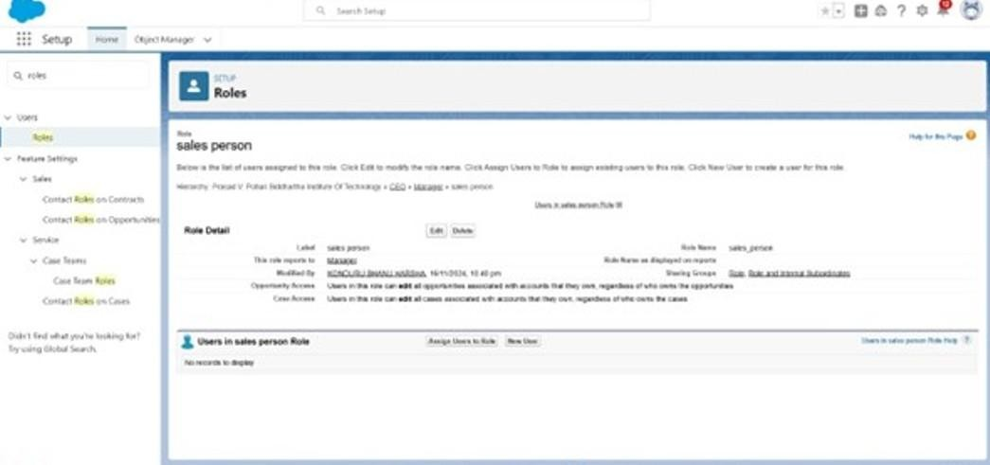

# Users

A user is anyone who logs in to Salesforce. Users are employees at your company,such as sales reps,managers, and IT specialists, who need access to the company's records. Every user in Salesforce has a user account. The user account identifies the user, and the user account settings determine what features and records the user can access.

## Create User

1. Go to setup >>type users in quick find box >>select users >>click New user.
2. Fill in the fields
   1. First Name : Niklas
   2. Last Name : Mikaelson
   3. Alias : Give a Alias Name
   4. Email id : Give your Personal Email id
   5. Username : Usernameshould be in this form: [text@text.text](mailto:text@text.text)
   6. Nick Name : Give a Nickname
   7. Role : Manager
   8. User licence : Salesforce
   9. Profiles : Manager
3. 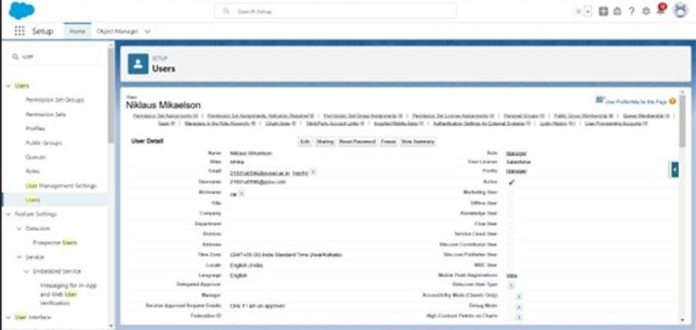Save.

## creating another users

1. Repeat the steps and create another user using
   1. Role : sales person
   2. User licence : Salesforce Platform
   3. Profile :sales person

## Note : creationist 3 users with these permissions.

**Public groups**

Public groups are a valuable tool for Salesforce administrators and developers to streamline user management, data access, and security settings. By creating and using public groups effectively, you can maintain a secure and organized Salesforce environment while ensuring that users have appropriate access to the resources they need.

## Creating New Public Group

1. Go to setup >>type users in quick find box >>select public groups>> click New.
2. Give the Label as “sales team”.
3. Group name is auto populated.
4. Search for Roles.
5. In Available Members select Sales person and click on add it will be moved to selected member.
6. Click on save.

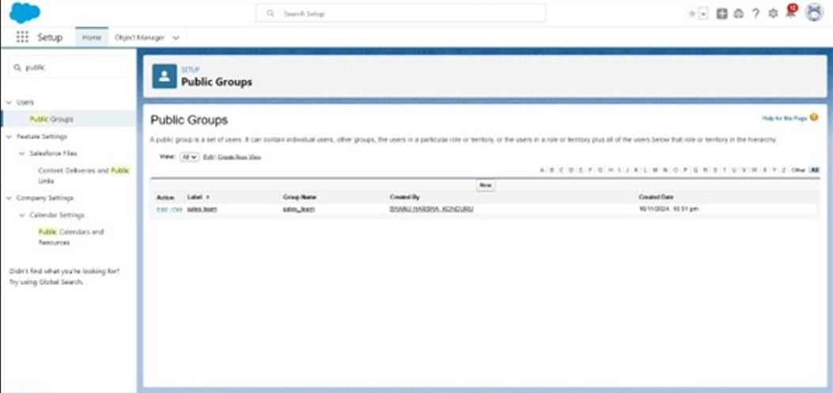

## Sharing Setting

Salesforce allows you to configure sharing settings to control how records are accessed and shared within your organization. These settings are crucial for maintaining data security and privacy. Salesforce provides a variety of tools and mechanisms to define and enforce sharing rules, such as:

## Organization-Wide Default (OWD) Settings:

These settings define the default level of access for all objects within your Salesforce org. OWD settings include Private, Public Read-Only, Public Read/Write, and Controlled by

Parent. OWD settings can be configured for each standard and custom object.

## Role Hierarchy:

Salesforce uses a role hierarchy to determine record access.

Users at higher levels in the hierarchy have greater access to records owned by or shared with users lower in the hierarchy.

The role hierarchy is often used in combination with OWD settings to grant different levels of access.

## Profiles and Permission Sets:

Profiles and permission sets allow administrators to specify object-level and field-level permissions for users. Profiles are typically used to grant general object and field access,while permission sets can be used to extend those permissions to specific users.

## Creating Sharing settings

1. Go to setup >>type users in quick find box >>select Sharing Settings>> click Edit.
2. Change the OWD setting of the Service records Object to private as shown in fig.
3. Click on save and refresh.
4. Scroll down a bit, Click new on Service records sharing Rules.
5. Give the Label name as “ Sharingsetting”
6. Rule name is auto populated.
7. In step 3 : Select which records to be shared,members of “ Roles ” >> “ Sales person”
8. In step 4: share with, select “ Roles ” >> “ Manager ” 9. In step 5 : Change the access level to “ Read / write ”. 10. Click on save.

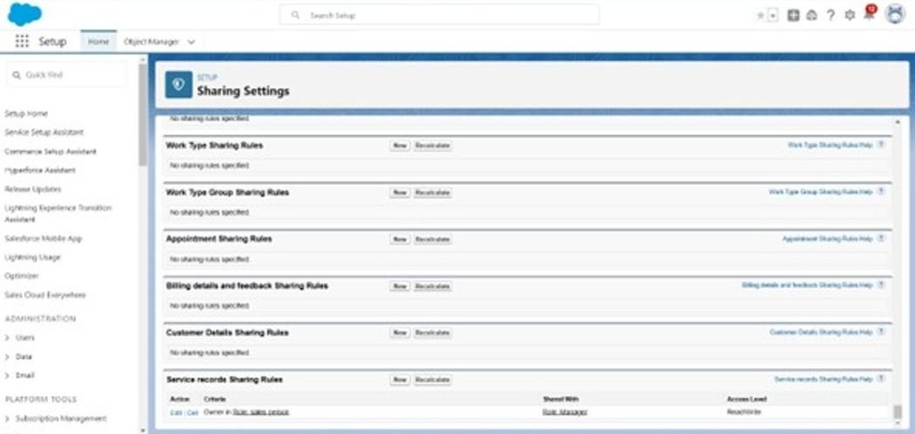

## Flows

**Create a Flow**

1. Go to setup >> type Flow in quick find box >>Click on the Flow and Select the New Flow.
2. Select the Record-triggered flow and Click on Create.
3. Select the Object as “Billing details and feedback”in the Drop down list.
4. Select the Trigger Flow when: “A record is Created or Updated”.
5. Select the Optimize the flow for: “Actions and Related Records”and Click on Done.
6. Under the Record-triggered Flow Click on “+” Symbol and In the Drop down List select the “Update records Element”.Give the Label Name : Amount Update
7. Api name : is auto populated
8. Set a filter condition : All Conditions are met(AND)
9. Field : Payment_Statusc
10. Operator : Equals
11. Value : Completed
12. And Set FieldValues for the Billing details and feedback Record
13. Field : Payment_Paidc
14. Value : {!$Record.Service_recordsr.Appointmentr.Service_Amountc}
15. Click On Done.Before creating another Element.Create a New Resource form Toolbox form top left.
16. Click on the New Resource, And select Variable.
17. Select the resource type as text template.
18. Enter the API name as “ alert”.
19. Change the view as Rich Text ? View to PlainText.
20. In body field paste the syntax that given below.

Dear {!$Record.Service_recordsr.Appointmentr.Customer_Namer.Name},

I hope this message finds you well. I wanted to take a moment to express my sincere gratitude for your recent payment for the services provided by our garage management team. Your prompt payment is greatly appreciated, and it helps us continue to provide top-notchservices to you and all our valued customers. Amount paid : {!$Record.Payment_Paidc}

Thank you for Coming .

1. Click done.
2. Now Click on Add Element, select Action.
3. Their action bar will be opened in that search for “ send email ” and click on it.
4. Give the label name as “ Email Alert”
5. API name will be auto populated.
6. Enable the body in set input values for the selected action.
7. Select the text template that created , Body : {!alert}
8. Include recipient address list select the email form the record.
9. RecipientAddressList:

{!$Record.Service_recordsr.Appointmentr.Customer_Namer.Gmailc}

1. Include subject as “ Thank You for Your Payment - Garage Management”.
2. Click done.
3. Click on save. Give the Flow label , Flow Api name will be auto populated.

## And click save,and click on activate.

**Apex Trigger**

Apex can be invoked by using triggers. Apex triggers enable you to perform custom actions before or after changes to Salesforce records, such as insertions, updates, or deletions.

A trigger is Apex code that executes before or after the followingtypesfollowing types: a. insert

1. update
2. delete
3. merge
4. upset
5. undelete

For example,you can have a trigger run before an object's records are inserted into the database, after records have been deleted, or even after a record is restored from the Recycle Bin.

You can define triggers for top-level standard objects that support triggers, such as a Contact or an Account, some standard child objects, such as a CaseComment, and custom objects. To define a trigger, from the object management settings for the object whose triggers you want to access, go to Triggers.

There are primarily two types of Apex Triggers:

## Before Trigger:

This type of trigger in Salesforce is used either to update or validate the values of a record before they can be saved into the database. So, basically, the before trigger validates the record first and then saves it. Some criteria or code can be set to check data before it gets ready to be inserted into the database.

## After Trigger:

This type of trigger in Salesforce is used to access the field values set by the system and affect any change in the record. In other words, the after trigger makes changes to the value from the data inserted in some other record.

## Apex handler

UseCase : This use case works for Amount Distribution for each Service the customer selected for there Vehicle.

1. Login to the respective trailhead account and navigate to the gear icon in the top right corner.
2. Click on the Developer console. Now you will see a new console window.
3. In the toolbar,you can see FILE. Click on it and navigate to new and create New apex class.
4. Name the class as “AmountDistributionHandler ”.

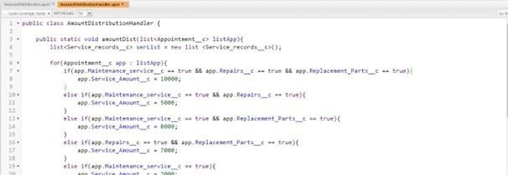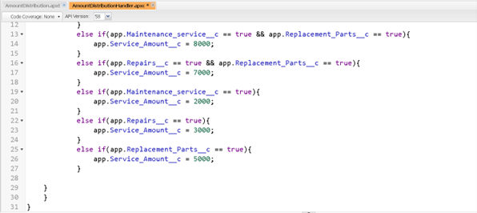

## Code:

public class AmountDistributionHandler { public static void amountDist(list<Appointment c> listApp){ list<Service_records c> serList = new list <Service_records c>(); for(Appointment c app : listApp){

if(app.Maintenance_service c == true && app.Repairs c == true && app.Replacement_Parts c == true){ app.Service_Amountc = 10000;

}

else if(app.Maintenance_service c == true && app.Repairs c == true){ app.Service_Amount c = 5000;

}

else if(app.Maintenance_service c == true && app.Replacement_Parts c == true){ app.Service_Amount c = 8000;

}

else if(app.Repairs c == true && app.Replacement_Parts c == true){ app.Service_Amount c = 7000;

}

else if(app.Maintenance_service c == true){ app.Service_Amount c = 2000;

}

else if(app.Repairs c == true){ app.Service_Amount c = 3000;

}

else if(app.Replacement_Parts c == true){ app.Service_Amount c = 5000;

}

}

}

}

## Trigger Handler :

How to create a new trigger:

1. While still in the trailhead account, navigate to the gear icon in the top right corner.
2. Click on developer console and you will be navigated to a new console window.
3. Click on File menu in the tool bar, and click on new? Trigger.
4. Enter the trigger name and the object to be triggered.
5. Name : AmountDistribution
6. sObject : Appointmentc

## Syntax For creating trigger :

The syntax for creating trigger is :

Trigger [trigger name] on [object name]( Before/After event)

{

}

In this project , trigger is called whenever the particular records sum exceed the threshold i.e minimum business requirement value. Then the code in the trigger will get executed.

## Code:

trigger AmountDistribution on Appointmentc (before insert,before update) { if(trigger.isbefore && trigger.isinsert || trigger.isupdate){

AmountDistributionHandler.amountDist(trigger.new);

}

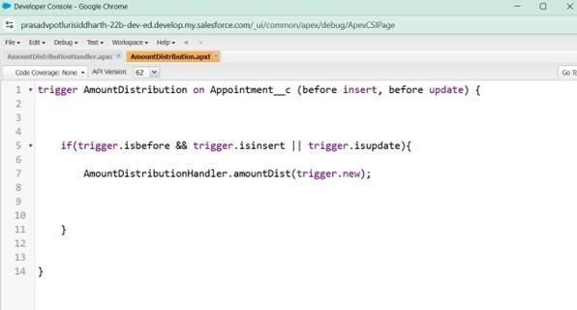}

## Reports

Reports give you access to your Salesforce data. You can examine your Salesforce data in almost infinite combinations, display it in easy-to-understand formats,and share the resulting insights with others. Before building, reading, and sharing reports, review these reporting basics.

Types of Reports in Salesforce

1. Tabular
2. Summary
3. Matrix
4. Joined Reports

## create a report folder

1. Click on the app launcher and search for reports.
2. Click on the report tab, click on new folder.
3. Give the Folderlabel as “GarageManagement Folder”, Folder unique name will be auto populated.
4. Click save.

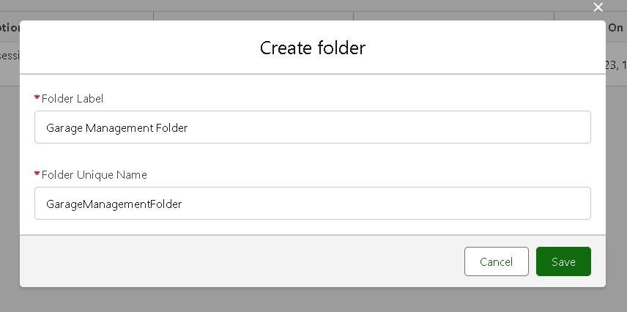

## Sharing a report folder

1. Go to the app >> click on the reports tab.
2. Click on the All folder, click on the Drop down arrow for Garage Management folder, and Click on share.
3. Select the share with as “roles”, in name field search for “manager”, give “view” as access for that role.
4. Then click share, and click on Done.

## Create Report Type

1. Go to setup >> type users in quick find box >>select Report Type >> click on Continue.
2. Click on new custom report type.
3. Select the Primary object as “ Customer details”.
4. Give the Report type Label as “ Service information ”
5. Report type Name is auto populated.
6. Keep the Description as same.
7. Select Store in Category as “ other Reports ”
8. Select the deployment status as “ Depolyed ”, click on Next.
9. now , Click on Related objectbobject box
10. on Select Object,choose Appointment Objectas shown in fig
11. Again Click to relate another object.
12. And select the related object as “ service records”.
13. Repeat the process and select the related object as “ Billing details and feedback”.
14. And click on save.

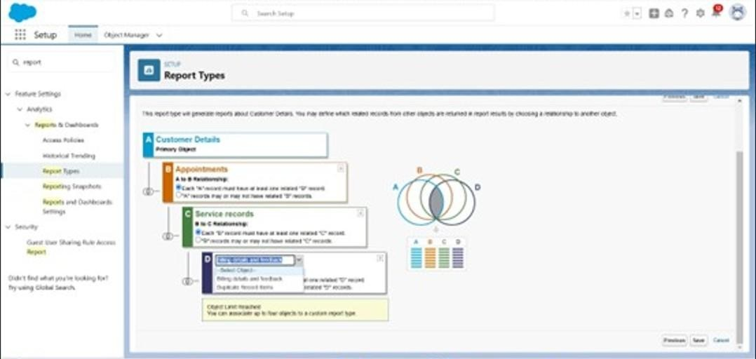

## Create Report

Note : Before creating report, create latest“10” records in every object. Try to fill every field in each record for better experience.

1. Go to the app >> click on the reports tab
2. Click New Report.
3. Select the Category as other reports,search for ServiceInformation, select that report, click on it. And click on start report.
4. Their outline pane is opened already, select the fields that mentioned below in column section.
   1. Customer name
   2. Appointment Date
   3. Service Status
   4. Payment paid
   5. Remove the unnecessary fields.
   6. Select the fields that mentioned below in GROUP ROWS section.
      1. Rating for Service
   7. Select the fields that mentioned below in GROUP ROWS section.
      1. Payment Status
   8. Click on Add Chart , Select the Line Chart.
   9. Click on save, Give the reportName : New Service information Report
   10. Report unique Name is auto populated.
   11. Select the folder the created and Click on save.

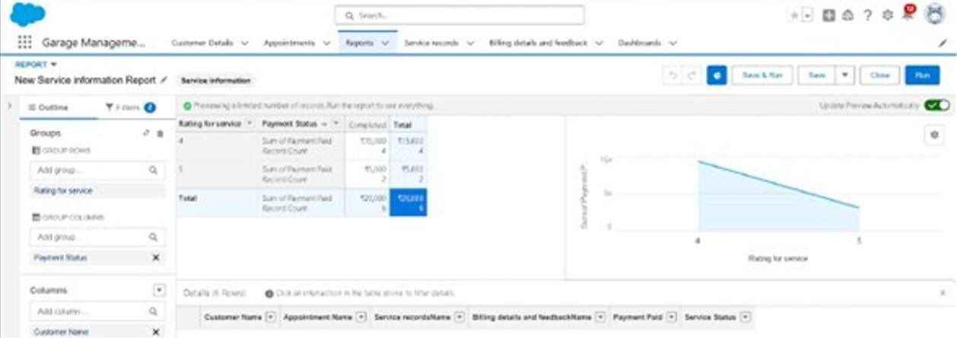

# Dashboards

Dashboards help you visually understand changing business conditions so you can make decisions based on the real-time data you’ve gathered with reports. Use dashboards to help users identify trends,sort out quantities, and measure the impact of their activities. Before building, reading, and sharing dashboards, review these dashboard basics.

## Create Dashboard Folder

1. Click on the app launcher and search for dashboard.
2. Click on dashboard tab.
3. Click new folder, give the folder label as “ Service RatingdashbRating dashboard
4. nique name will be auto populated.
5. Click save.
6. Follow the same steps, form milestone 15, and activity2, and provide the sharing settings for the folder that just created.

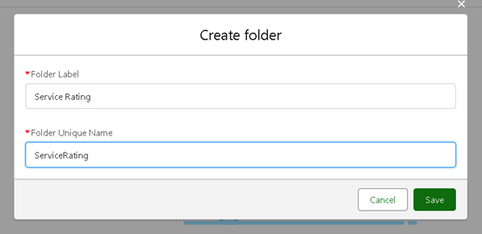

## Create Dashboard

1. Go to the app >> click on the Dashboards tabs.
2. Give a Name and select the folder that created, and click on create.
3. Select add component.
4. Select a Report and click on select.
5. Select the Line Chart.Change the theme.
6. Click Add then click on Save and then click on Done.
7. Preview is shown below.

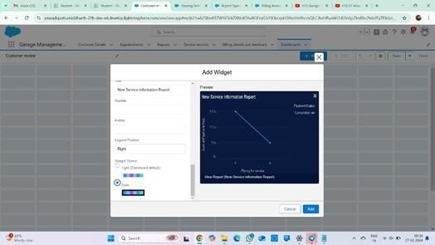

## Subscription:

1. After that Click on Subscribe top right.
2. Set the Frequency as “ weekly”.
3. Set a day as mon day.
4. And Click on save.

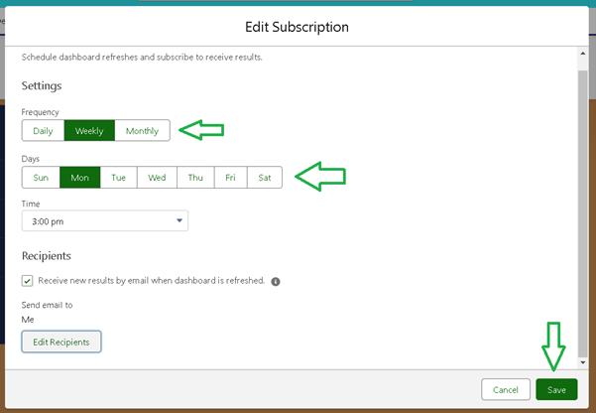

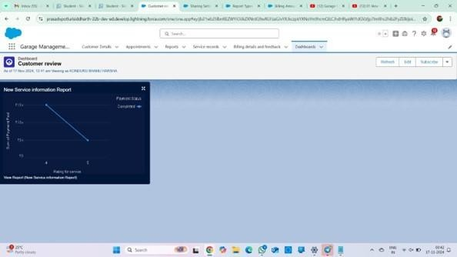

**Conclusion:**

The implemented Salesforce Garage Management System (GMS) represents a robust and integrated solution designed to modernize and optimize the operations of automotive repair facilities. By strategically leveraging both Salesforce's declarative (clicks-based) and programmatic (code-based) capabilities, the system effectively manages the core aspects of garage operations. This includes streamlined appointment scheduling, comprehensive vehicle tracking, detailed service record management, efficient billing processes, and systematic collection of customer feedback.

The architectural design, characterized by the strategic application of custom objects and fields, ensures a flexible and adaptable data model capable of capturing the unique information requirements of a garage. Furthermore, the meticulous implementation of validation rules and duplicate rules critically upholds data integrity, preventing erroneous entries and maintaining a clean, reliable dataset. Automated processes, powered by Salesforce Flows and Apex Triggers, significantly streamline operational workflows, from calculating service amounts based on complex logic to automating payment confirmations and customer communications.

A well-defined security model, meticulously crafted through the configuration of Profiles, Roles, Public Groups, and Sharing Settings, ensures that data privacy is rigorously maintained and that appropriate access control is enforced for all users. This layered security approach safeguards sensitive information while facilitating necessary collaboration. Finally, the integration of comprehensive reporting functionalities and interactive dashboards empowers data-driven decision-making. These analytical tools allow garage management to gain real-time insights into key performance indicators, identify operational trends, and ultimately optimize performance to foster lasting customer relationships. This project establishes a strong and scalable foundation for an efficient GMS, with inherent potential for future enhancements such as seamless integration with external accounting systems, expansion into mobile service capabilities, or the development of advanced predictive maintenance analytics.